Son of Gas volume and limiting reagent  CλeMis+ry: http://genest.weebly.com  Stop in for help every day at lunch and Tues &Thurs after school! | 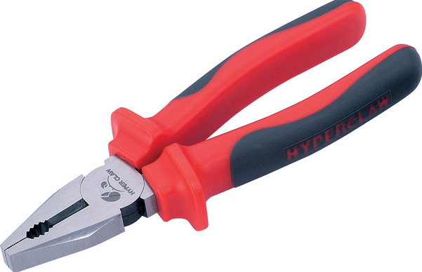 | Name_____________  Period_____________

- What does STP stand for?

- At STP what is the pressure? ________________________________

- At STP what is the temperature? _____________________________

- Describe all gases at STP, by filling in the blanks:

__________ moles of gas at STP = ______________ liters of gas

- 2. A 90.0 mL volume of helium was collected under a pressure of 740 mmHg. At what volume would the pressure of this gas be 700 mm Hg? Assume temperature is constant.

- A small bubble rises from the bottom of a lake, where the temperature is 8˚C and the pressure is 6.4 atm, to the water’s surface, where the temperature is 25˚C and pressure is 1.0 atm. Calculate the final volume (in mL) of the bubble if its initial volume was 2.1 mL.

- Determine the volume in liters of carbon dioxide that should be produced in the reaction between 100. g of carbon and 100. liters of O2. (Use the same three steps as in the previous problem above).

- Suppose 10.61 g of calcium was allowed to react with 8.61 liters of HCl gas to produce calcium chloride and hydrogen gas.
  - What is the balanced equation?

  - Which reactant is limiting? (Show both calculations.)

  - Using the limiting reactant, solve for how many liters of hydrogen gas will form at Standard Temperature and Pressure.

- Suppose 55.00 L of nitrogen gas and 103.00 L of hydrogen gas are mixed and reacted to form ammonia (NH₃). Calculate the volume in liters of ammonia produced when this reaction runs to completion.

- Gold (III) sulfide can react with fluorine to form gold(I) fluoride gas and S₈. Write a balanced reaction and then find how many liters at STP of AuF will form if you have 333.3 grams Gold (III) sulfide and 7.1 liters fluorine.

