How do Odd Formula Ions Dissolve?  CλeMis+ry: http://genest.weebly.com  Stop in for help every day at lunch and Tues,&Thurs after school!  After-hours question? Email me at home: eagenest@madison.k12.wi.us |  | Name_________  Period________

- Circle the metallic element in each.
Circle any element that is a metal | This substance is… | When one of these dissolves, how many aqueous ions form? |  | Circle any element that is a metal | This substance is… | When one of these dissolves, how many aqueous ions form?
CuSO_{4(s)} | ionic / molecular |  |  | Na₂C₂O_{4(s)} | ionic / molecular
N₂O_{4((g)} | ionic / molecular |  |  | H₃PO₄ | ionic / molecular

space to take lecture notes:

- Draw three aluminum bromides in the left beaker:  AlBr_{3(s)}  AlBr_{3(s)}  AlBr_{3(s)} | 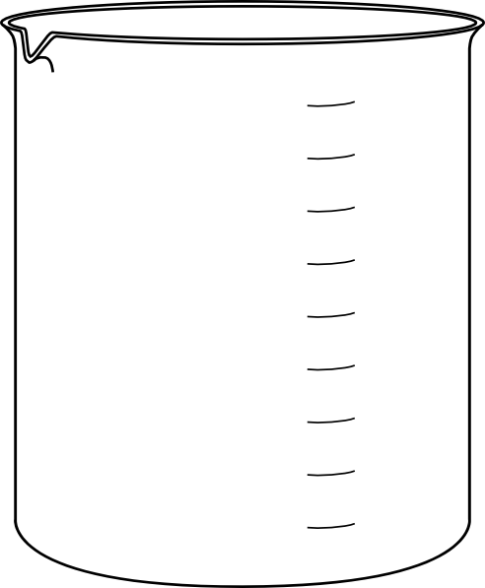  SOLID |  | AQUEOUS

- Draw a slash through the molecule to show the half that would fall off. How many pieces will this fall apart into if made into an aqueous solution? (circle your choice)
KI | 1? 2? 3? 4? 5? | AlBr₃ | 1? 2? 3? 4? 5?
K₂S | 1? 2? 3? 4? 5? | (NH₄)₂CO₃ | 1? 2? 3? 4? 5?
MgCO₃ | 1? 2? 3? 4? 5? | Ca(CH₃COO)₂ | 1? 2? 3? 4? 5?
Zn(NO₃)₂ | 1? 2? 3? 4? 5? | CH₃OH | 1? 2? 3? 4? 5?

- True / False: Mark (T) true or (F) in each blank
  - ____ solutions are heterogeneous mixtures
  - ____ solutions are clear
  - ____ the dissolved substance will eventually settle out of a solution

- For each, write a dissociation equation (something like "A(s) -> B(aq) + C(aq)") .
Include charges (+1, +2, etc) and phase notation (s, L, g, aq)
  - K₂S_{(s)} dissolving. Show each ion separately.
________ --> ________ + ________ + ________
  - CO_{2(s)} dissolving.
________ --> ________
  - Zn(NO₃)₂ dissolving. Show each ion separately.
________ --> ________ + ________ + ________
  - Mg(C₂H₃O₂)_{2(s)} dissolving. Show each ion separately.
________ --> ________ + ____________ + ____________
  - HC₂H₃O_{2(L)} dissolving. Show each ion separately.
________ --> ________ + ____________ + ____________
- Drawings!
  - In the beaker on the left, draw the indicated solid, repeating the formula three times.
  - In the beaker on the right, draw what the substance would look like with water added.
- Draw two ammonium carbonates in each beaker:  (NH₄)₂CO₃  (NH₄)₂CO₃ | SOLID |  | AQUEOUS

- For each molecule below circle a choice to indicate how many particles you would
expect it to form in solution.
(a) C2H3OH 1 particle 2 particles 3 particles 4 particles 5 particles
(b) SO3 1 particle 2 particles 3 particles 4 particles 5 particles
(c) Li3PO4 1 particle 2 particles 3 particles 4 particles 5 particles
(d) FeF3 1 particle 2 particles 3 particles 4 particles 5 particles

- Now try redoing your earlier anser with a coefficient in front of each particle. For example, instead of writing Br- Br- Br- it is more common and esier to write a coefficient: 3Br-
  - K₂S_{(s)} dissolving. Use a coeffiecient where appropriate.
________ --> ________ + ________
  - Zn(NO₃)₂ dissolving. Use a coeffiecient where appropriate.
________ --> ________ + ________

