Mole to mol/L  CλeMis+ry: http://genest.weebly.com  Stop in for help every day at lunch and Tues &Thurs after school! | 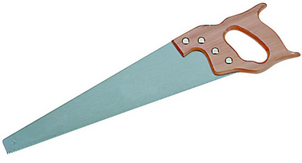 | Name_____________  Period_____________

- The formula for calculating molarity is concentration = $\frac{number of particles}{volume of solution}$

Rewrite this formula by just putting the name of the proper units in each space below:

[ ] =

- For this aqueous solution
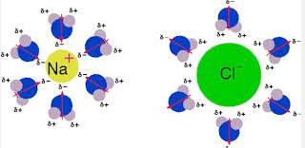

The solute is ________________ The solvent (hint: it’s aqueous) is ________________

- At home, whipped cream is made by just quickly beating some liquid cream until it foams up.
The solute is ________________ The solvent is ________________
- Under a microscope, smoke is mostly tiny particles of graphite.
The solute is ________________ The solvent is ________________

- What is the concentration of a solution made by adding 9.84 moles of NH₃ gas to water to form a solution that has a volume of 3.50 liters?

- Write the memorized formula we use for calculating molarity:

- Rearrange that formula to solve for moles (“Get the word moles by itself on one side of the equals sign by using algebra.”.)

- Rearrange the formula from #6 to solve for volume (“Get the word moles by itself on one side of the equals sign by using algebra.”.)

- Calculate the molarity of 2.3 moles of potassium chloride in 0.45 liters of solution.

- Calculate the molarity of 1.2 moles of calcium carbonate in 1.22 liters of solution.

- Calculate the molarity of 0.09 moles of sodium sulfate in 12 mL of solution.

- What is the concentration of a solution made by adding 9.84 moles of NH₃ gas to water to form a solution that has a volume of 3.50 liters?

- Tell how many moles of NaCl you would need to prepare 75 mL of a 0.1 M NaCl solution. (Fix your units first!)

- How many moles of CuSO4 must be dissolved to make 39 mL of aqueous solution that has a concentration of 0.22$\frac{mol}{L}$?

- The unit for molarity can be written as $\frac{mol}{L}$? What’s another symbol for molarity? _____

