Review Sheet  Hand this in for credit! Due Thursday! |  | Name_________  Period________

- Convert 593 mmHg into atm

The following questions are about PAIRS of boxes that contain gas particles hitting their walls.
Match each description to one or more pairs of boxes  - _____ In this pair the box on the left has greater pressure  - _____ In this pair the box on the right has greater pressure  - _____ In this pair, one of the boxes has more pressure because the volume is less  - _____ In this pair, one of the boxes has more pressure because the temperature is greater  - _____ In this pair, one of the boxes has more pressure because the number of particles is greater  - Of these six boxes, the box that has the least total pressure in it is in (A / B / C ), the (Left / Right ) box | A.
 | B.
 | C.
- How could two different containers of gas have the exact same pressure, even though one of them has double the temperature? (more than one correct answer is possible)
______________________________________________________________________________

- Illustrate your answer to the previous question with a picture that shows two boxes, some particles, and arrows to show the motion of the particles, similar to the particle drawings shown in A, B, C above.

- When temperature of a gas increases, its pressure will ( increase / decrease )
- When volume of a gas increases, pressure will ( increase / decrease )
- What is noteworthy about the vibrations of molecules at Absolute Zero?

- It is common to assume that a mole of gas has a volume of 22.41 liters at standard temperature and pressure. According to the chart at the right the substance that behaves most like an ideal gas is _______________  - Does any real gas behave the same as ideal gas? _______  - From your notes, list two things that you could do to chlorine to make it behave more like an Ideal Gas.  ________________________________  ________________________________ | 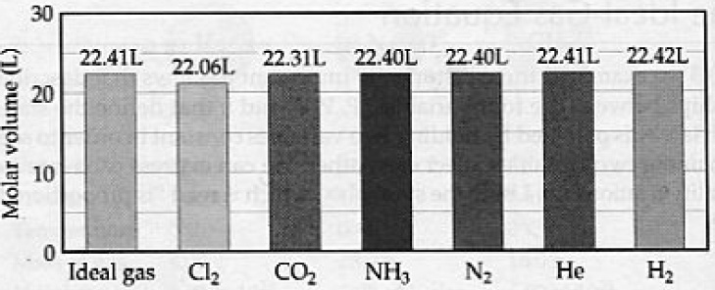
- What is the effect of the following on the volume of an ideal gas?
a) The pressure is tripled (at constant T) and the temperature is halved.

b) The pressure is decreased to 1/4 and the temperature in kelvins is doubled

- When measured at STP a quantity of gas has a volume of 450 mL. What volume in milliliters will it occupy at -10.0°C and 93.3 kPa?
Check one box.
This problem can be solved with:
□ just the $\frac{P_{1}V_{1}}{T_{1}}$ = $\frac{P_{2}V_{2}}{T_{2}}$ formula
□ just the PV=nRT formula
□ a balanced equation and the
PV=nRT formula

- When number of gas atoms increases, pressure will ( increase / decrease )

- A 1.25 gram sample of CO₂ is contained in a 0.750 L flask at 22.5°C. What is the pressure of the gas?
Check one box.
This problem can be solved with:
□ just the $\frac{P_{1}V_{1}}{T_{1}}$ = $\frac{P_{2}V_{2}}{T_{2}}$ formula
□ just the PV=nRT formula
□ a balanced equation and the
PV=nRT formula

- If 55.22g copper(II) oxide reacts with 12.52L carbon dioxide at STP, what mass of copper II carbonate (recall that carbonate is CO₃²⁻) will be formed?
  - Write a balanced equation.

  - Use PV = nRT to find how many moles of carbon dioxide are present.

  - Do a series of unit conversions to answer the question.

- According to $\frac{V_{1}}{T_{1}}$ = $\frac{V_{2}}{T_{2}}$ what is the volume of any gas at -273 °C?
- The pressure in kilopascals at STP is _____________
- A quantity of gas exerts a pressure of 98.6 kPa at a at a temperature of 22.0 °C. If the volume remains unchanged, what pressure will it exert at -8.0°C?
Check one box.
This problem can be solved with:
□ just the $\frac{P_{1}V_{1}}{T_{1}}$ = $\frac{P_{2}V_{2}}{T_{2}}$ formula
□ just the PV=nRT formula
□ a balanced equation and the
PV=nRT formula

- According to kinetic molecular theory, how does the motion of gas particles cause pressure?

________________________________________________________________________________
- Write the temperature of absolute zero in °C ? ____________

How accurate is this antique illustration of the first ever hydrogen balloon? In 1783, Jacques Charles exploited the cutting edge discovery of hydrogen gas by filling a bag of rubber and silk and sailing it on a 45 minute journey. Upon landing the balloon was torn to shreds by pitchfork-wielding peasants. | - Using visual clues and the formula for volume of a sphere ( V = $\frac{4}{3}πr^{3}$), estimate the cubic meters of the great gas bag in the picture below. Assume the height of a man is 2 meters.. Then convert the volume to liters  using 1000 L = 1 m³
- Contemporary accounts that Monsieur Charles took 70 hours to fill the balloon using 450000 grams of iron (about 200 pounds of iron) in the following reaction.
2Fe + 3H₂SO₄ --> 3H₂ + Fe₂(SO₄)₃
How many liters of gas should this recipe have made?
- Assuming that your result for #2 is the 'accepted value', calculate your % error for the volume you estimated in #1
 | 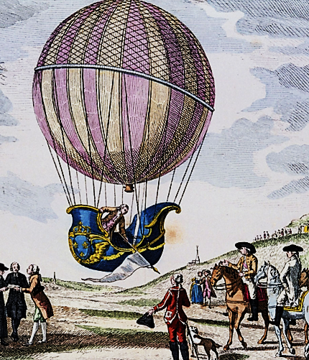
Work space for solving the above problems:

