Name_______________________________________________________________________Hr._____________
Heating and Cooling Lab : Stearic acid
- Prediction: Circle how you think the temperature will change as we let the hot liquid cool off and turn into a solid:
This? This? This? This? Or draw your own!
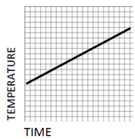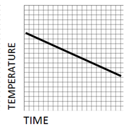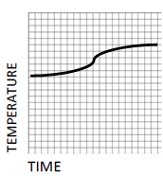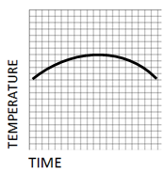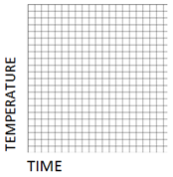
- Temperature and time are [circle one](inversely* / directly * ) related.
[*Inversely means, when one grows the other shrinks. Directly means, when one grows, the other grows.]
- Fill a 400 mL beaker full of distilled water.
- Heat the water using a bunsen burner until it reaches the temperature of 75°C. Use a thermometer not in the solid to measure the temperature. Keep in mind you should not place the thermometer on the bottom of the beaker.
- Once the water has reached 75°C place the test tube containing stearic acid in the warm water using a test tube clamp. You do not want the test tube to be touching the bottom of the beaker.
- Record the temperature of the stearic acid using the thermometer in the solid every 20 seconds. Be sure to maintain the temperature at 75°C. Don’t exceed 80°C! This may require you to add and remove the heat. You do not want the water to drop below 75°C. You only need to record temperature until it is completely melted.
- While you are waiting fill a second 400 mL beaker with 35°C water. This will require you to add water from your water beaker (75°C) to reach the 40°C.
- Place the test tube from the warm beaker into the cool beaker and record the temperature every 20 seconds until it re-freezes. Your first temperature will follow the last temperature from the heating. This may take more than 20 seconds, but as long as you keep the test tube in the warm water beaker it will not change the graph. Keep in mind you may not use all of the table or many need to add to the table.

Seconds | Temp (°C) |  | Seconds | Temp (°C) |  | Seconds | Temp (°C) |  | Seconds | Temp (°C) |  | Seconds | Temp (°C)
0 |  |  | 200 |  |  | 400 |  |  | 600 |  |  | 800
20 |  |  | 220 |  |  | 420 |  |  | 620 |  |  | 820
40 |  |  | 240 |  |  | 440 |  |  | 640 |  |  | 840
60 |  |  | 260 |  |  | 460 |  |  | 660 |  |  | 860
80 |  |  | 280 |  |  | 480 |  |  | 680 |  |  | 880
100 |  |  | 300 |  |  | 500 |  |  | 700 |  |  | 900
120 |  |  | 320 |  |  | 520 |  |  | 720 |  |  | 920
140 |  |  | 340 |  |  | 540 |  |  | 740 |  |  | 940
160 |  |  | 360 |  |  | 560 |  |  | 760 |  |  | 960
180 |  |  | 380 |  |  | 580 |  |  | 780 |  |  | 980

- Estimate what the freezing point is of your substance_____________°C
- What is the melting point of your substance?_____________ °C
- From your teacher, obtain the accepted melting point of this substance. Record it here:________
- Calculate your percent error.

Homework: Graph your data from the front side
TEMPERATURE [°c]
TIME (SECONDS)

13. How would your graph be different if you had more stearic acid in the test tube?

